**Aim:** Design a LED Flasher

**Apparatus:** ⦿ Arduino Board

⦿ LED

⦿ Resistance (220 Ω)

⦿ Wires

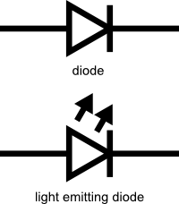**Theory:** LEDs are a particular type of diode that convert electrical energy into light. LED stands for ‘*Light Emitting Diode*’. In 1962, Nick Holonyak, Jr. invented the first LED that could produce visible red light. LEDs are comprised of compound semiconductor materials, which are made up of elements from group III and group V of the periodic table, commonly used to make LEDs are gallium arsenide (GaAs) and gallium phosphide (GaP). This is reflected in the similarity between the diode and LED schematic symbols:

LED flashers are semiconductor integrated circuits used to turn on and off groups of light emitting diodes either sequentially or according to a programmed pattern. They are found in circuits used as indicators and controllers, as well as in home-built projects.

**Problems & Troubleshooting:**

1. Problem in fixing wire from bread board to Arduino.
2. Problem in writing Arduino programming.
3. Problem in finding the Positive and negative terminal of LED.

**Precautions:**

1. Correct connection of negative and positive terminal of led.
2. Don’t put Arduino board near water.
3. Check the USB port of computer is working.
4. Check the Arduino software and select the correct port (in which Arduino is connected).

**Learning Outcome:**

1. Arduino function as a controller in led chaser.
2. Bread board is used to organize the circuit.
3. Learned how to recognize the positive and negative terminal of LEDs even without using a multimeter.

**Observation:**

1. The LED glows like a Flash.
2. Insert the Jump Wire in correct mentioned Pin.

**Circuit Diagram:**

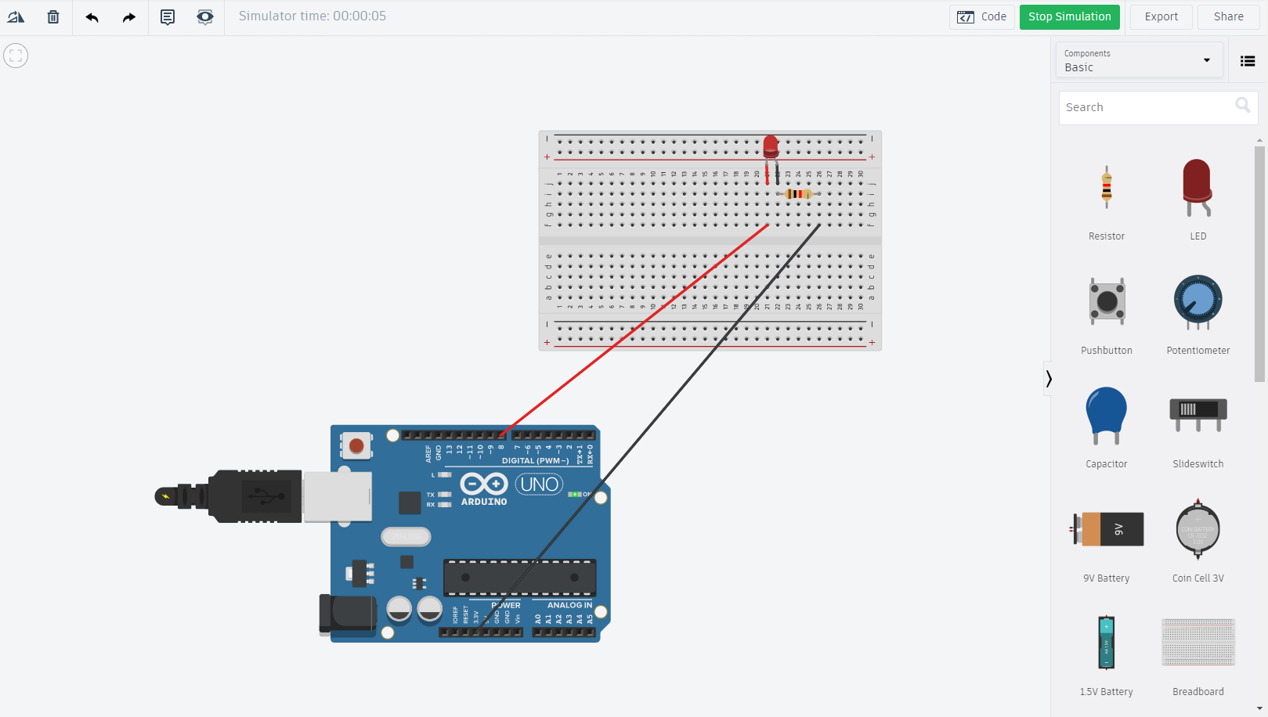*Source code/Program in Code File.ino

**Result:** Blinking of LED was verified after uploading the program.